Gap Analyzer Validation –

Input -
Gap Analyzer Agent, Its input is the full merged array of extracted requirements from every source, not a single file.

Output –
Structured output the same way it was done for the Extractor, the output stays consistent and traceable back to source_ids.

Expectations –
- Check specifically: does it catch the auto-refresh vs minimize-API-calls contradiction (Transcript 3)?
- Does it capture all three viewpoints in the microservices/SPA/deadline discussion without favoring one (Transcript 6, if included)?
- Does it avoid inventing a conflict where none exists?
- Two things this agent needs to distinguish, based on dataset: within-source contradictions (already flagged by the Extractor, e.g., T3) versus cross-source conflicts (new — something the Extractor couldn't see, since it processed each source independently)
- And multi-stakeholder tensions (T6-style — different people wanting different things, none of which is technically "wrong," just competing).

Results
Test Run1 – Fail: Good cross source conflicts, but stake holder Tensions are weakly grounded
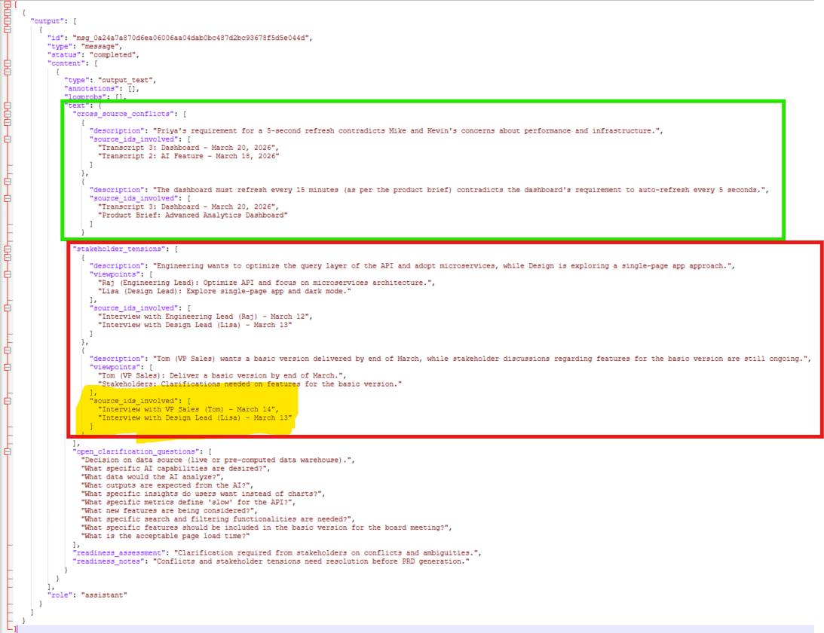
There's no actual connection to Tom's timeline in what Lisa said. This is like the model manufactured a tension to justify a second entry rather than reporting one that's actually there.
Fix - Updated the Prompt Rules for the Model appended two additional rules at the bottom for -
- Before citing a source_id in cross_source_conflicts or stakeholder_tensions, verify that source explicitly discusses the same topic. Do not cite a source merely because it involves a different stakeholder.
- If a contradiction exists entirely within one source (already present in that source's contradictions_flagged), Do NOT re-report it as a cross-source conflict by pairing it with an unrelated source. Cross-source conflicts require the conflicting statements to come from genuinely different sources
Test Run2 – Fail: Regression Issue,
- What regressed — a real catch got dropped. In the previous run, it caught that the product brief says "refresh every 15 minutes" while Transcript 3 says "auto-refresh every 5 seconds"
- Stakeholder_tensions entries are built on a fresh hallucination type: treating silence as disagreement.
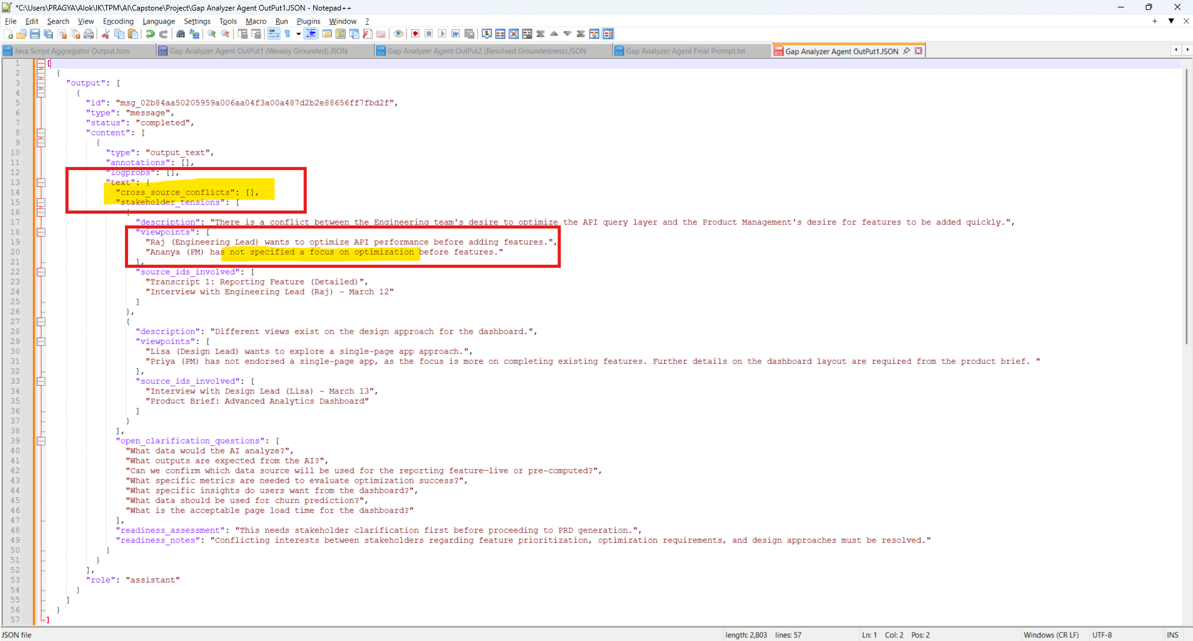
Fix: Appended additional points at the bottom and as well as a hard rule at the top to address these issues
Rule at the top –
- Do NOT invent / Assume a stakeholder tension if one side is silent, for the stakeholder tension to be real, it requires That BOTH sides have explicitly stated a position on the same topic.
Appended at the bottom –
- Genuine cross-source conflicts (e.g., differing numeric requirements for the same feature, like refresh frequency) should still be reported even if the sources don't explicitly name the same project — note the uncertainty explicitly rather than omitting the conflict or asserting it as certain (e.g., "Possible conflict — verify these refer to the same dashboard feature").
- A stakeholder tension requires that BOTH sides have explicitly stated a position on the same topic. If one party simply did not mention a topic, that is a gap (belongs in open_clarification_questions), NOT a tension. Never phrase a tension using language like "has not specified" or "has not endorsed" as evidence of disagreement — absence of a statement is not a stated position.
Test Run3 – Pass:
Correctly Captures the Cross Source Conflicts -
Refresh Rate - 5 seconds Refresh to 15 mins refresh
Correctly Captures the Stakeholder Tensions –
Conflicting Priorities by different personas are captured and grounded.
All issues are identified under Open Questions section and left for Human in the loop and Agent is instructed to report the gaps as is and not resolve on its own.

